Task 1: VLAN Network Diagram
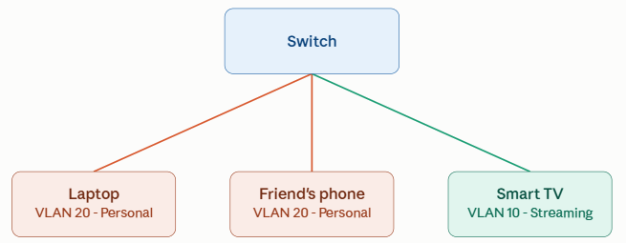

VLAN 10 (Streaming / IoT Media):
- Device: Smart TV connected to Switchport FastEthernet0/1
- Subnet: 192.168.10.0/24
VLAN 20 (Personal Devices):
- Device 1: User Laptop connected to Switchport FastEthernet0/2
- Device 2: Friend's Phone (via Access Point bridging to Switchport FastEthernet0/3)
- Subnet: 192.168.20.0/24

Task 2: Configuring two VLANs on a simulated switch

1. Topology & IP Scheme
- VLAN 10 (Faculty / Lab 1): Subnet 192.168.10.0/24
  - PC1: 192.168.10.11 connected to Fa0/1
  - PC2: 192.168.10.12 connected to Fa0/2
  - PC3: 192.168.10.13 connected to Fa0/3
- VLAN 20 (Students / Lab 2): Subnet 192.168.20.0/24
  - PC4: 192.168.20.14 connected to Fa0/4
  - PC5: 192.168.20.15 connected to Fa0/5
2. Cisco Switch CLI Configuration Commands
Switch> enable
Switch# configure terminal
! --- Create VLANs ---
Switch(config)# vlan 10
Switch(config-vlan)# name Faculty_VLAN
Switch(config-vlan)# exit
Switch(config)# vlan 20
Switch(config-vlan)# name Student_VLAN
Switch(config-vlan)# exit
! --- Assign Ports to VLAN 10 ---
Switch(config)# interface range FastEthernet0/1 – 3
Switch(config-if-range)# switchport mode access
Switch(config-if-range)# switchport access vlan 10
Switch(config-if-range)# exit
! --- Assign Ports to VLAN 20 ---
Switch(config)# interface range FastEthernet0/4 – 5
Switch(config-if-range)# switchport mode access
Switch(config-if-range)# switchport access vlan 20
Switch(config-if-range)# exit
Switch(config)# end
3. Verification & Connectivity Testing
- Verification: show vlan brief
- Intra-VLAN Ping (Within VLAN 10):
  - From PC1 terminal: ping 192.168.10.12
  - Result: Successful replies (0% packet loss).
- Inter-VLAN Ping (Across VLAN 10 to VLAN 20):
  - From PC1 terminal: ping 192.168.20.14
  - Result: Request timed out (100% packet loss).
Reason: VLANs create separate logical networks. Communication between different VLANs requires a router or Layer 3 switch.

Task 3: Moving a PC from VLAN 10 to VLAN 20

Scenario: PC3 (connected to interface FastEthernet0/3) is moved from VLAN 10 to VLAN 20.
Step 1: Before State Configuration
Check port assignment: Switch# show vlan brief
Output before change:
Plaintext
VLAN Name Status Ports
---- -------------------------------- --------- -------------------------------
10 Faculty_VLAN active Fa0/1, Fa0/2, Fa0/3
20 Student_VLAN active Fa0/4, Fa0/5
- Connectivity Test: PC3 (192.168.10.13) can ping PC1 (192.168.10.11), but cannot ping PC4 (192.168.20.14).
Step 2: Configuration Reassignment
Switch# configure terminal
Switch(config)# interface FastEthernet0/3
Switch(config-if)# switchport access vlan 20
Switch(config-if)# exit
Switch(config)# end
Switch# do wr
Step 3: Device IP Reconfiguration
On PC3, change the static IP address to match the new subnet:
- Old IP: 192.168.10.13 / 255.255.255.0
- New IP: 192.168.20.13 / 255.255.255.0
Step 4: After State Verification
Switch# show vlan brief
Output after change:
Plaintext
VLAN Name Status Ports
---- -------------------------------- --------- -------------------------------
10 Faculty_VLAN active Fa0/1, Fa0/2
20 Student_VLAN active Fa0/3, Fa0/4, Fa0/5
- Connectivity Test:
  - Ping from PC3 (192.168.20.13) to PC4 (192.168.20.14): Successful (Reply received)
  - Ping from PC3 (192.168.20.13) to PC1 (192.168.10.11): Fails (Request timed out)

Task 4: Assigning 10 ports to VLAN 30 using Automated Port Configuration

Switch# configure terminal
Switch(config)# vlan 30
Switch(config-vlan)# name Guest_Network
Switch(config-vlan)# exit
! Batch configure ports FastEthernet0/1 through FastEthernet0/10
Switch(config)# interface range FastEthernet0/1 - 10
Switch(config-if-range)# switchport mode access
Switch(config-if-range)# switchport access vlan 30
Switch(config-if-range)# spanning-tree portfast
Switch(config-if-range)# no shutdown
Switch(config-if-range)# exit
Switch(config)# end
Switch# do wr

